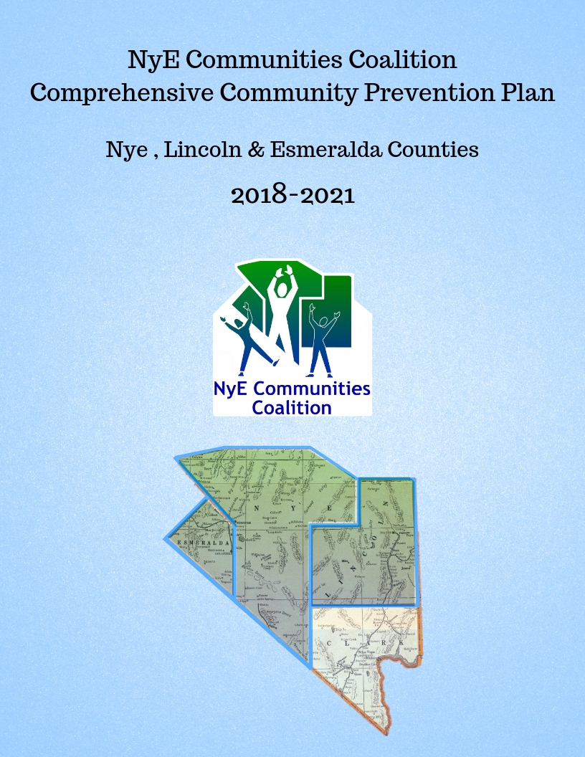

Contents
NyE Communities Coalition 3
NYECC Vision 3
NYECC Mission 3
Strategic Planning Framework 4
Eight Dimensions of Wellness 5
Seven Strategies for Community Change 6
SPF Step 1: Plan - Needs Assessment 7
Nye County- County Health Rankings 8
Lincoln County Heath Rankings 12
Esmeralda County Heath Rankings 16
Nye, Esmeralda and Lincoln Counties- Youth Risk Behaviors Survey (YRBS) 19
NyECC Youth Substance Abuse Summary 28
SPF Step 2: Capacity 31
SPF Step 3 & 4: Planning and Implementation 33
3-Year Strategic Initiative 36
Data Driven Decision Making 36
Data Access for Partners 36
SPF Step 5: Evaluate 37
Program Evaluation 37
Sustainability 37
Public Trust 38
Cultural Competence 38

NyE Communities Coalition
NYECC

NYECC is a non-profit community-based coalition founded in 2002. NYECC provides substance abuse prevention across Nye, Lincoln and Esmeralda Counties through engagement concerned citizens, key community leaders and organization. NYECC is governed by a volunteer Board of Directors.

The 2018-2021 Comprehensive Community Prevention Plan includes an overview of the substance abuse in Nye, Lincoln and Esmeralda Counties. Local and statewide data is presented, the capacity to address substance abuse issues is discussed, a strategic plan is provided and evaluation efforts explained.

NYECC Vision
Grow H.O.P.E.
Healthy Organizations, People and Environments

NYECC Mission

The mission of NyE Communities Coalition is to grow healthy organizations, people and environments (HOPE), across Nye, Esmeralda and Lincoln Counties by joining together individuals, organizations, and agencies in a cooperative and collaborative effort to increase services and opportunities.

Stacy Smith
Chief Operating Officer
NyE Communities Coalition
1020 East Wilson Road
Pahrump, NV 89048
(775) 727-9970 ext. 240
stacy@nyecc.org

Mary Duff
Director of Community Building
NyE Communities Coalition
1020 East Wilson Road
Pahrump, NV 89048
(775) 727-9970 ext. 237
mary@nyecc.org

Strategic Planning Framework
NYECC HOPE Committee meets on a quarterly basis and is composed of Assessment, Planning and Evaluation (APE) Committee. This committee works to follow the SPF process when looking at prevention efforts throughout the NYECC service area. Each step of the SPF model can occur in any order. This is not a linear process.

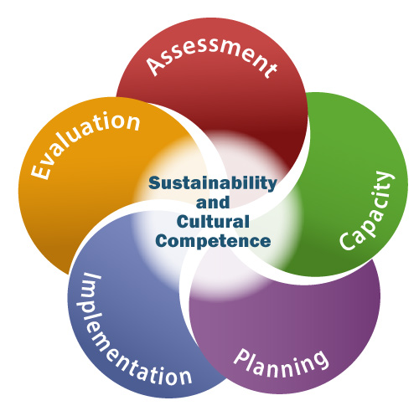
Step 1: Assess Needs What is the problem, how can we learn more?

This step helps the coalition members identify needs around substance abuse and the contributing factors. By review of different data sources, the prevention efforts can be targeted to the needs of the community. Data helps to prioritize, identify local conditions and assess readiness and resources to address these factors. Through engagement of the coalition members, buy-in, support and sustainability is being work towards.

Step 2: Build Capacity What resources do we have to work with?
This step allows for the coalition members identify resources and build local readiness to address the substance abuse issue. Both human and structural resources are accounted for during this step. By making sure prevention efforts are well supported helps to build-up the sustainability component.

Step 3: Plan What should we do and how should we do it?
In this step, a logic model is often developed. This allows for the risk and protective factors to be fully identified and the correct interventions to be selected. Through strategic planning, the most appropriate programming can be identified and barriers can be overcome.

Step 4: Implementation How can we put the plan into action?
During this step, the strategic prevention plan is put into action. Work with partners to make sure programming is successful. Consider fidelity and adaption issues.

Step 5: Evaluate Is the plan succeeding?
Evaluation is the systematic collection and analysis of information about the program. This step is not just about the collection of data but using this data to improve the effectiveness of the prevention program.
Cultural Competence
The ability to interact effectively with members of a diverse population.
Sustainability
The process of achieving and maintaining long-term results.

Eight Dimensions of Wellness

Mental and physical health are linked, problems in one area can impact the other. It is important to make choices that will improve both the mental and physical health in order to achieve wellness and a high quality of life. In the 8 Dimensions of Wellness it is important to have a balance between the different components.

Social Wellness is the ability to relate to and connect with other people.

Emotional Wellness is the ability to understand ourselves and cope with the challenges of life.

Spiritual Wellness is establishing peace and harmony in one’s life.

Environmental Wellness being able to recognize our own responsibility for the air, water and land that surrounds us, and understanding the importance of a healthy environment.

Occupational Wellness is the ability to get personal fulfillment from our jobs or our careers while maintaining balance.

Intellectual Wellness being able to open our minds to new ideas and experiences and having the desire to learn new concepts, improve skills and seek healthy challenges.

Physical Wellness includes maintaining a healthy quality of life, the ability to recognize that our behaviors impact our wellness and adopting healthful habits and avoiding destructive habits such as substance use and abuse.

Financial Wellness is having an understanding of your financial situation and taking care of it in such a way that you are prepared for financial changes.
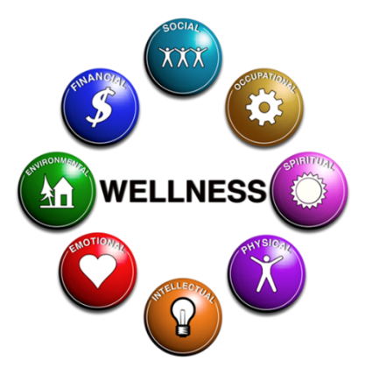

Seven Strategies for Community Change

NYECC uses the Seven Approaches to Achieve Community Change, as defined in the Implementation Primer provided by CADCA, to maximize the efforts of the coalition. These approaches include:

Providing Information - educational presentations, seminars, trainings, PSAs, brochures, community meetings, and social marketing.

Enhancing Skills – workshops, seminars, activities designed to increase the skills of participants, trainings and technical assistance.

Providing Support – creating opportunities to support people in participating in activities, providing alternative healthy/substance free activities, mentoring, referrals.

Enhancing Access/Reducing Barriers – improving systems and processes within the communities we live in, increase the ease, ability and opportunity to utilize those systems and services.

Changing Consequences – increasing or decreasing the probability of a specific behavior that reduces the risk or enhances the protection by increasing public recognition and rewards for positive choices and increasing taxes, citations, fines, revocations/loss of privileges for negative choices.

Physical Design – changing the physical design or structure of the environment to reduce risk or enhance protection.

Modifying/Changing Policy – formal change in written procedures, by-laws, proclamations, rules or laws which include workplace initiatives, law enforcement procedures and practices, public policy, systems change within government, communities and organizations.

SPF Step 1: Plan - Needs Assessment
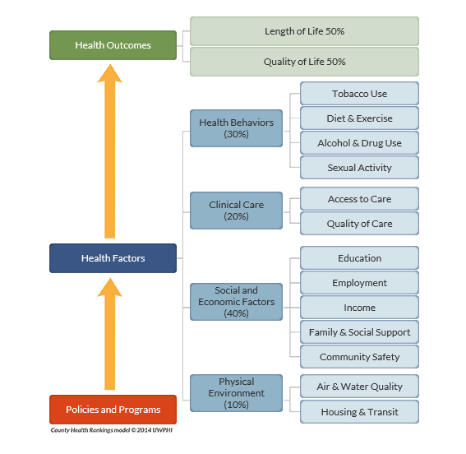
The below diagram allows for understanding of the different factors, and the weight of these factors, used to determine health outcomes and health factors in the County Health Rankings. For example, when looking at Health Outcomes thee length of life and quality of life are the two factors and are equally weighted. For the Health Factors, social and economic factors are the heaviest weighted at 40% and are composed of education, employment, income, family and social support and community safety. Health factors are weighed at 30% and tobacco use, diet and exercise, alcohol and drug use and sexual activity are looked at. Clinical care is weighted at 20% and composed of access to care and quality of care. Physical environment is weighted at 10% and composed of air and water quality and housing and transit.

In Nevada, Nye County is ranked the least healthy (16 out of 16) for health outcomes and 15 out of 16 for health factors. Lincoln County is on the other end of the spectrum for health outcomes being ranked 3 out of 16 and 5 out of 16 for health factors. Although Nevada has 17 counties, Esmeralda County does not have sufficient data to be ranked.

Nye County- County Health Rankings
1.1
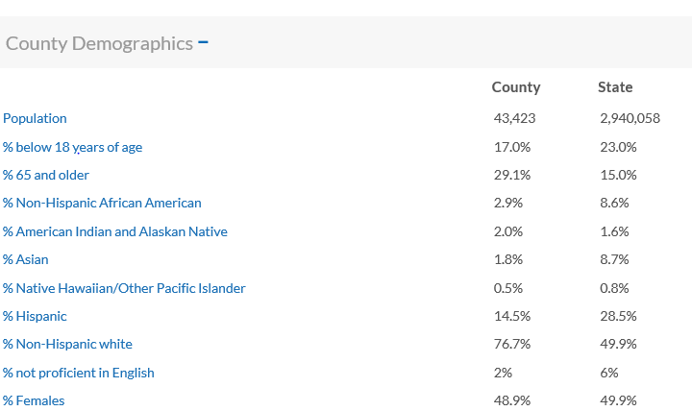

1.1 This demographic information shows that Nye County has a high percentage of the elderly, 65 years of age and older, living within the county. Also, most the county is composed of non-Hispanic white with the remaining 24% being minority groups, the largest of which is Hispanic at 14.5%.
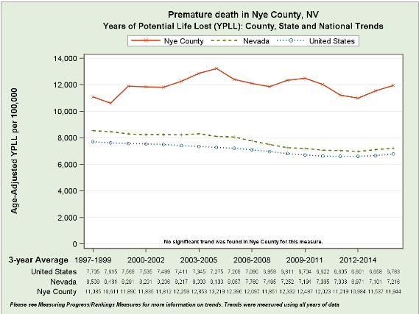
1.2

1.2 Premature death measures the risk of dying before the age of 75. This measure is age- adjusted so that counties with an older population are fairly compared to other counties across the nation. This statistic can be a very important factor in poor health. Nye County has a premature death rate at 11,500, which is higher than Nevada at 7,100.

1.3
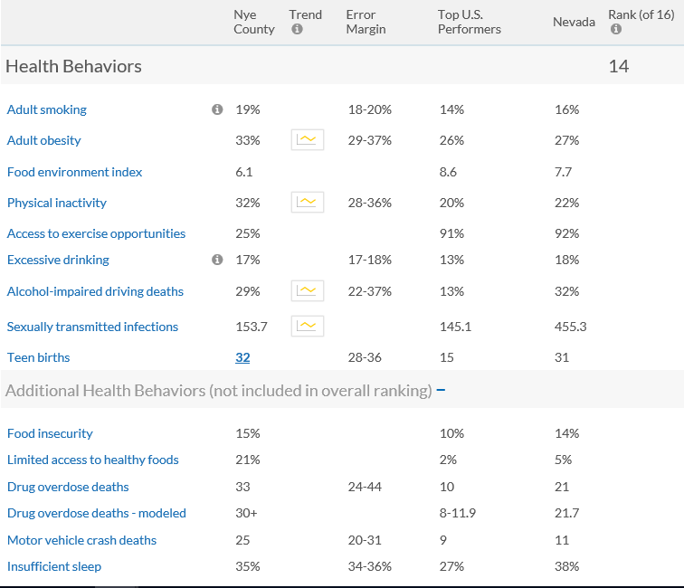

1.3 In regards to substance use, Nye County shows an adult use of tobacco at 19% higher than both the national and Nevada average. The alcohol impaired driving deaths is at 29%. This is calculated by taking the total driving deaths and comparing it to the deaths that involved alcohol. It is important to recognize that a five-year average is used here. 17% of Nye County residents excessively drink determined by past 30-day binge drinking on the Centers for Disease Control (CDC) Behavioral Risk Factor Surveillance System (BRFSS). Drug overdose deaths are a leading contributor to the premature death rate. Across the nation, we have seen an increase of drug overdose deaths. The drug overdose deaths include accidental, unintentional and underdetermined overdoses. Nye County as 33 per 100,000 population compared to National average 10 and Nevada average 21.7. The drug overdose deaths-modeled is looking at the range based on population of 100,000.

In regards to nutrition and physical activity there are several factors to review. First, 15% of Nye County residents are food insecure, meaning that there is not adequate access to food. While 21% of residents to not have access to healthy foods. The healthy food index is ranked 0 (least healthy) to 10 (most healthy) and are composed of two factors: access to healthy foods and food insecurity. Nye County is ranked 6.1 out of 10. In 2016, the average value for counties was 7.0. In Pahrump, there are three main grocery stores: Walmart, Smiths and Albertsons. These are located “up town” about two miles away from one another. May residents who live on either side of town likely exceed the 10 miles criteria be labeled a food desert. Amargosa is about 40 miles one-way from Pahrump and has very little food resources available, one small market and a community garden that was began the summer of 2018. There are no food pantries that support this area. The residents of Beatty are located further down Highway 95 and are about 75 miles one-way from Pahrump. Beatty has experienced recent changes with their food security needs, including the closure and re-opening of their small grocery store located in the RV Park. Additionally, Beatty has a dollar store that carries canned foods; however, the access to fresh produce is minimal. Residents of Amargosa and Beatty travel to Pahrump for their big grocery needs. Tonopah has a grocery store Reilley’s to support them.

One if four people do not have access to exercise opportunities. Given these statistics, it is no surprise that one in three, or 33%, of Nye County residents are obese.

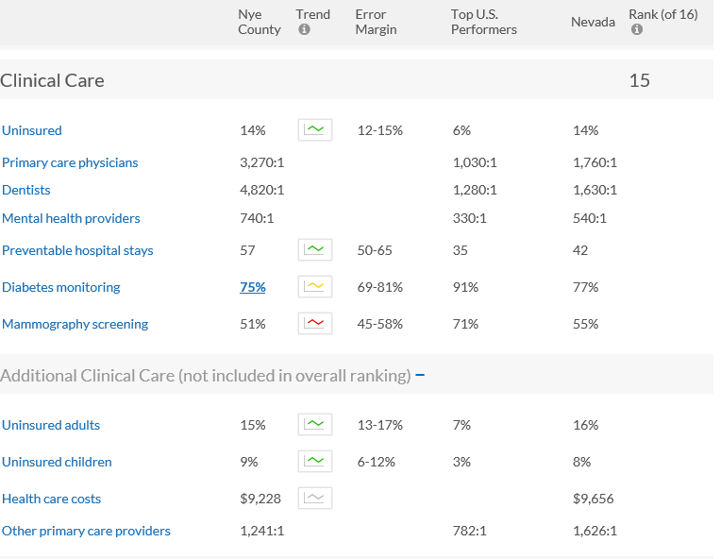
1.4

1.4 For the primary care physicians, dentists, mental health providers, and other primary care providers the ratios of the population per 1 professional is provided. For example, there is one primary care physician per 3,720 individuals in Nye County. On top of this shortage of professionals, 15% of adults and 9% of children in Nye County are uninsured.

1.5
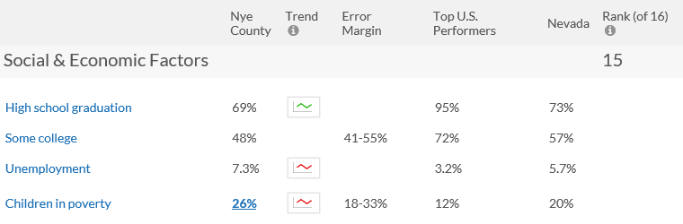

1.6

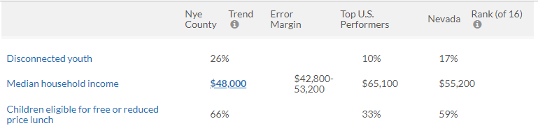

1.5 & 1.6 It is alarming that 26% of the youth 18 and under in Nye County are considered to be living in poverty. Additionally, 66% of K-12 students across Nye County are enrolled in public schools that are eligible for free or reduced price lunch. Furthermore, the graduate rate is 69% meaning that less than one if four youth are not receiving the basic education of a high school diploma. Considering this statistic, it comes as no surprise the 26% of Nye County residents 16-24 years of age are considered to be disconnected youth-neither in school or employed. The unemployment rate across the County is 7.3% higher than the national and Nevada average.

Lincoln County Heath Rankings
2.1
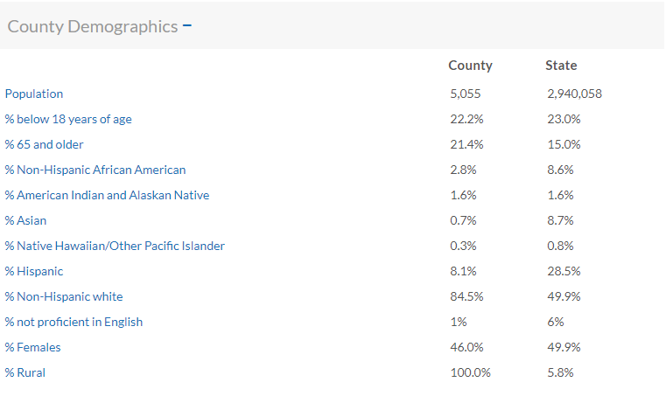

2.1 This demographic information shows that Lincoln County has a fairly even range of ages with one in five being youth under the age of 18 and one in five being seniors at 65 years of age and over. About 85% of the population is Non-Hispanic White with only 15% of those living in the population are minorities.

2.2
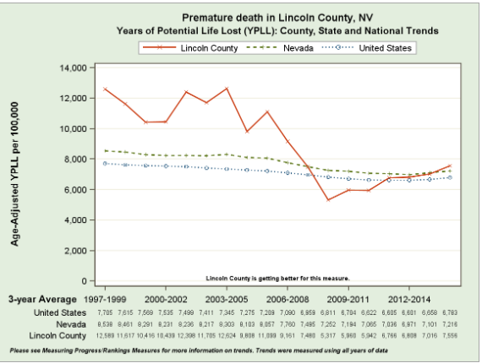

2.2 Looking at the Premature death rates in Lincoln County it can be seen that up to 2008 the county experienced higher rates than Nevada and the Nation; however, there was a sudden drop at that time. Although it looks like there is a steady rise in the years since 2008, the rate is comparable to both Nevada and the Nation.

2.3
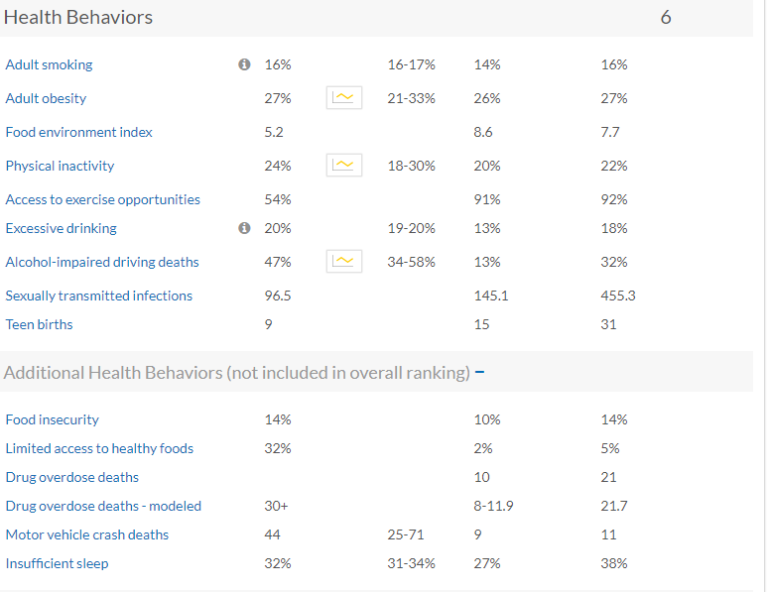

2.3 The alcohol-impaired driving deaths is alarmingly high at 47%. Taking a deeper dive into this data that was collected from 2012-16, there were a total of 15 driving deaths with 7 of them having an alcohol-impaired driver involved. One in five, or 20%, of Lincoln County residents report excessive drinking determined from the CDC BRFSS.

The drug overdose deaths-model is an estimate of the number of deaths due to drug poisoning per 100,000 population. The accidental, intentional, and undetermined poisonings. For Lincoln County 30+ is higher than the Nevada and National average.

While food insecurity is equal to the Nevada average, the access to healthy foods is limited as 32% of the Lincoln County of low-income populations does not live within 10 miles to a grocery store. Pioche does not have a grocery store in their town. The closest store is the Panaca Market with is located in Panaca, 12 miles away. At this time, the Panaca Market does not accept Supplemental Nutrition Assistance Program (SNAP) benefits so SNAP recipients in both Pioche and Panaca are traveling to Caliente for the grocery shopping needs. For Pioche this is 25 miles, or 50 miles round trip. For Panaca this is 15 miles away, or 30 miles round trip. The food environment index for the county is a low 5.2 out of 10.

While 54% of Lincoln County residents have access to physical activity opportunities. This is determined by living within three miles of recreational facilities, such as a gym, or parks like local, state and national. Lincoln County has five State Parks: Kershaw-Ryan, Beaver Dam, Cathedral Gorge, Echo Canyon and Spring Valley. There are extensive bike riding trails that draw in locals and tourists alike. Currently, there are several grants that are supporting the development of even more trails. However, Lincoln County is spread across 10,637 square miles with Alamo, Caliente, Panaca, Pioche, Rachel and Ursine. NYECC believes that although outdoor recreational activities are available this statistic is high due to the distance factor of three miles.

2.4
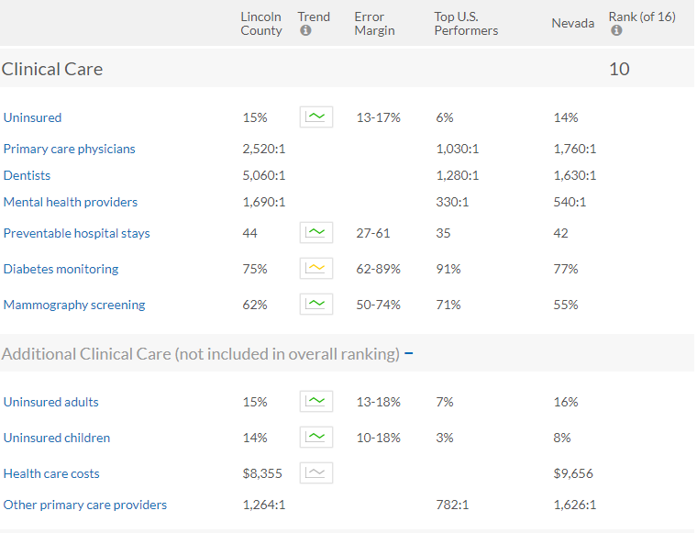

2.4 The Grover C Dils Medical Center is located in Caliente and offers a 24-hour emergency and other medical services. However, Lincoln County still shows a shortage of primary care physicians, dentists, and mental health providers. For example, there is one dentist for every 5,060 residents in Lincoln County. On top of this shortage, 15% of adults and 14% of children are uninsured.

2.5
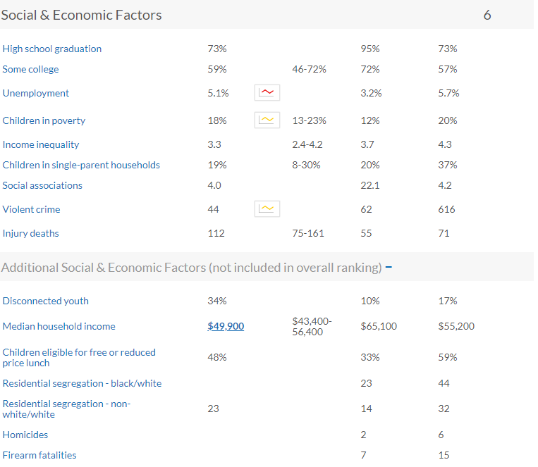

2.5 Disconnected youth means youth who are 16-24 years of age who are neither working nor in school. In Lincoln County there are 34% of youth who are disconnected. Although the graduation rate is 73%, equal to Nevada’s average, this still means that about one in four youth are not graduating high school and completing the most basic level of education. The unemployment rate is a little lower than the State’s average at 5.1%.

There seems to be a high rate injury death for the county. 112 deaths per 100,000 is shown in the above chart. NYECC is not sure why this rate is high; however, speculates that this may be a result of the popularity off roading and racing has within the county

Esmeralda County Heath Rankings
3.1
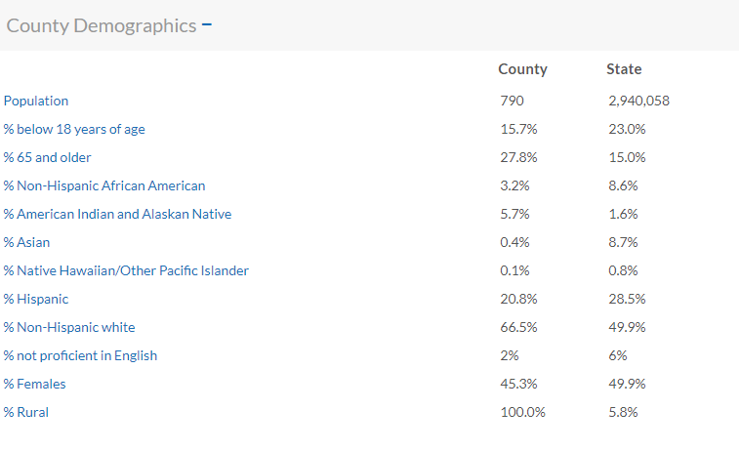

3.1 The demographic data for Esmeralda shows that although Non-Hispanic White is the majority of the population at approximately 66.5% there is a little more than 30% of the population made up of minorities. In fact, one in five Esmeralda residents are Hispanic. This makes Esmeralda County the most racially diverse in the NYECC service area.

3.2
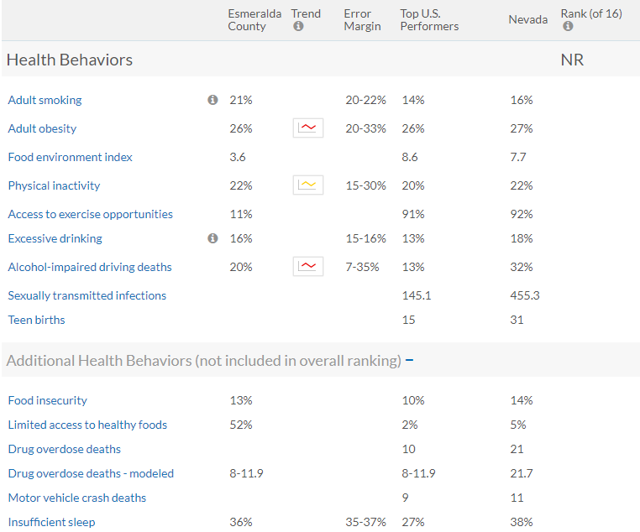

3.2 One in five Esmeralda residents smoke tobacco. Alcohol-impaired driving deaths is 20% of accidents. In 2012-16 there were 15 driving deaths, 3 of which were the result of alcohol impairment.
52% of residents in the county have limited access to food, meaning that they live 10 or more miles from a grocery store and the Food environment index is 3.6 out of 10. One in five report being physical inactive while 26% of the population is considered obese.

3.3
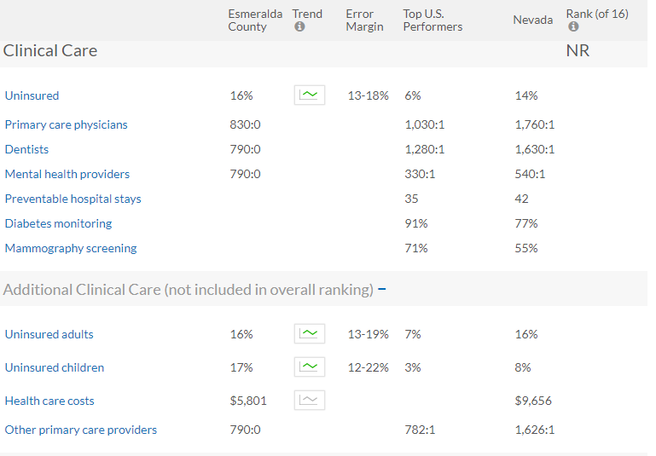

3.3 There are no medical facilities in Esmeralda so there are no primary physicians, dentists, mental health providers or other primary care providers within the county. 16% of adults and 17% are uninsured as well.

3.4
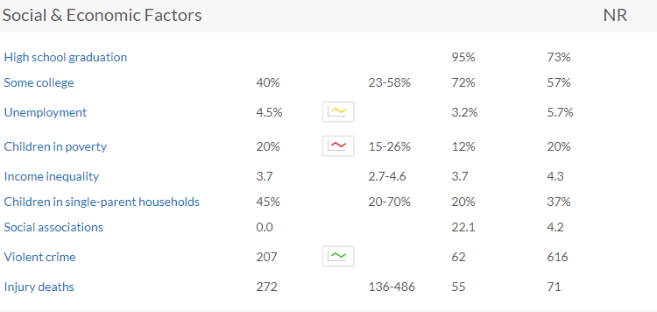
3.4 One in five youth live in poverty while close to half live in a single parent household. Injury death rate is considerably high with 272. This statistic NYECC would like to explore further.

Nye, Esmeralda and Lincoln Counties- Youth Risk Behaviors Survey (YRBS)

The Youth Risk Behavior Survey (YRBS) is conducted by the CDC and is a valuable tool when assessing the risk behaviors or school-aged youth. In Nevada, there is a middle school and high school YRBS survey. The University of Nevada Reno helps to analyze these results. Beginning 2017, these results have been grouped by coalition service area. Nye, Esmeralda and Lincoln Counties data is being grouped together. The YRBS is administered every two years to every grade level across the middle and high school. Nye and Esmeralda County are both active parental permission and Lincoln County is passive parental permission. As a result the data is more represented by Lincoln County youth which is noted as a generally healthier community with less drug use than Nye especially. Additionally as it is administered every two years there is the concern that the current situation regarding marijuana use is not fully identified. Anecdotal information and key information reflects that the legalization and Nye County, especially Pahrump’s enthusiastic adoption of growing and selling not only marijuana but also hemp is changing the current norms quickly.

First NYECC will review the middle school data and then the high school data. Review the tobacco use and electronic vapor product use, alcohol use, marijuana use, other drug use, diet, physical activity and emotional health.

- Percentage of middle school students who ever used cigarettes- 10.2%
- Percentage of middle school students who ever used electronic vapor products- 15.3%

- Percentage of middle school students who smoked a cigarette for the first time before 11 years of age: 3.9%
- Percentage of middle school students who used electronic vape products for the first time before 11 years of age: 4.9%

- Percentage of middle school students who used smokeless tobacco during the 30 days before the survey- 2.0%
- Percentage of middle school students who smoked cigars during the past 30 days before the survey- 2.1%
- Percentage of middle school students who used tobacco during the past 30 days before the survey- 3.6%
- Percentage of middle school students who used electronic vapor products during the 30 days before the survey- 4.1%

This data tells us a story for our community. While more middle school students have tried electronic vape (e-vape) products to cigarettes in middle school the percentage e-vape products is 15.3. Whereas the number of students who reported using these e-vape products before the age of 11 is considerable low at 4.9% at cigarettes at 3.9%. This data tells that the majority of students are who report ever trying these products are starting in their middle school years. However, the 30 day use responses means that although some students have tried these products there are only a small number of students using them regularly, the most of which is the e-vape products at 4.1%.

- Percentage of middle school students who ever drank alcohol- 21.4%

- Percentage of middle school students who drank alcohol for the first time before the age of 11 years of age- 11.4%

- Percentage of middle school students who drank alcohol during the 30 days before the survey-4.1%

This data tells us that one in five middle school students have tried alcohol in their lifetime. One in ten of these students in prior to the age of 11. However, only 4.1% of middle school students report regularly consuming alcohol. There were 17.8% of students who reported that they had ridden in a car or other vehicle with someone who had been drinking alcohol. This YRBS that about 17% of middle school students have ridden with someone who had been drinking alcohol supports the County Health Rankings data that 29% of driving deaths involved alcohol.

- Percentage of middle school students who ever used marijuana- 5.5%

- Percentage of middle school students who used marijuana for the first time before the age of 11 years of age- 1.4%

- Percentage of middle school students who used marijuana during the 30 days before the survey-3.7%

Of the 3.7% of middle school students who reported using marijuana regularly, 100% reported smoking it in a joint, bong, pipe or blunt. This tells us that even though Pahrump has a recreational dispensary the middle school students are not using the edible or other products as a method of marijuana use.
Other Substance Used | Ever Tried
Synthetic Marijuana | 1.1
Cocaine | 2.5
Inhalants | 5.2
Heroin | 1.0
Methamphetamines | 0.6%
Ecstasy | 0.5%
Prescription Medication | 5.3%

Substance Used | Ever/Currently | 2013 | 2015 | 2017
Alcohol | Ever Used | 38.5% | 37.5% | 26.5%
Marijuana | Ever Used | 13.2% | 12.5% | 8.2%
Cocaine | Ever Used | 4.4% | 4.1% | 3.6%
Inhalants | Ever Used |  |  | 6.8%
Prescription drugs | Ever Used |  |  | 6.6%
Cigarettes | Ever Used | 25.6% | 25.7% | 10.5%
 | Currently Using | 7.0% | 8.2% | 2.1%
Smokeless Tobacco | Currently Using |  |  | 1.%
Cigars | Currently Using | 7.6% | 5.9% | 1.9%
Electronic Vapor | Ever Used |  |  | 20.3%
 | Currently Using |  |  | 5.8%
Data Trends for Substance Use in Middle School Students

The three-year trends for alcohol, tobacco, and drug use for high school students are generally encouraging, as most rates are dropping, if even slightly, according to the YRBS survey. One exception is the percentage of students reporting ever using cigarettes in 2013 and 2015, which stayed virtually the same, then declining sharply in 2017. While these results are generally encouraging, the percentage of students trying substances such as alcohol are still high (26.5% in 2017). Additionally, data such as inhalant use, prescription drug use, smokeless tobacco use, and electronic vapor use have only been tracked for one year, making trend analysis impossible.

Percentage of middle school students who ate breakfast all 7 days before the survey- 55.7%

Percentage of middle school students went hungry because there was not enough food in the house during the 30 days before the survey- Never- 89.8%; Sometimes-8.1%; Most of the time/Always- 2.1%

Percentage of middle school students who were physically active at least 60 minutes/day on 5 or more days during the 7 days before the survey- 64%.
Percentage of middle school students who attended physical education classes daily- 30%
Percentage of middle school students who played on at least one sports team run by their school or community group during the 12 months before the survey-67.8%

These statistics around diet and physical activity are encouraging. Despite 26% of Nye County children living in poverty (County Health Ranking) there seems to be program and services in place that are able to meet the food needs of these middle school students. Also, many of the middle school students have the opportunity to participate in an extracurricular sport at some point during the year.

In regards to emotional health there are many questions on the YRBS that relate. NYECC will highlight a few in the CCPP.

29.9% of middle school students reported being bullied in the past 12 months. 13.5% reported that the bullying that occurred was “electronically bullied” which NYECC assumes to be through cyber bullying on social media platforms or through use of text messages. 22.4% of middle school students reported feeling sad or hopeless almost every day for two or more weeks in a row. 15.1% of middle school students reported ever seriously considering to kill themselves, 11.2% made a plan about how they would kill themselves, and 5.9% of middle school students attempted suicide. It is encouraging to NYECC that 40% of middle school students reported getting the kind of help they need when they feel sad, empty, hopeless, angry or anxious.

NYECC received the Safe Schools Healthy Students Grant from 2013-2018 that worked to build up systems and infrastructure at both a community-level and school-based approached in Nye County. Students are now able to be screened for Signs of Suicide and work with mental health professionals within the schools to get the help and support needed.

However, there is still room for improvement as 41.4% reported never/rarely getting the kind of help they need when they feel sad, empty, hopeless, angry or anxious.

Suicide – Trend Data

Action | 2007 | 2009 | 2017
Seriously Considered Suicide | 22.3% | 22.4% | 20.2%
Made a Plan | 15.1% | 13.8% | 14.7%
Attempted Suicide | 10.1% | 8.8% | 8.1%

According to YRBS data, suicide thoughts have remained relatively stable with a slight drop in 2017, suicide plans have increased slightly from 2009, and attempted suicides have generally declined, though only slightly from 2009 to 2017. The following table summarizes the YRBS trend data.

8.5% of middle school students said that they had experienced being hit, beaten kicked or physically hurt by an adult. 11.6% of middle school students said they had seen or heard adults in their home slap, hit, kick, punch or beat one another. Finally, 7.5% of middle school student responded that most of the time/always they had been sworn at, insulted by, or put down by an adult whereas 15.8% responded that this sometimes happens. Looking at these two statistics together, about one in five middle school students have experienced this from an adult.

Now NYECC will review the high school data and then the high school data. Review the tobacco use and electronic vapor product use, alcohol use, marijuana use, other drug use, diet, physical activity and emotional health. This data is only inclusive of Nye and Lincoln Counties.

- Percentage of high school students who ever used cigarettes- 27.2%

- Percentage of high school students who smoked a cigarette for the first time before 13 years of age: 10%

- Percentage of high school students who used a cigarette during the 30 days before the survey- 5.9%
- Percentage of high school students who smoked a cigarette on 20 or more days during the 30 days before the survey- 2.3%

While more than one in four high school students have ever smoked a cigarette it does not seem to be a habit for most students. 5.9% of students reports regularly smoking cigarettes while only 2.3% reported smoking on more than 20 days in the past month. It does seem that one in ten try cigarettes before the age of 13 with the majority initiating use in the high school years. Of the 5.9% of students who reported regularly smoking 5.2% bought their own cigarettes. This data tells NYECC that compliance checks may help limit the access to cigarettes as well as raising the minimum age to purchase tobacco to 21 years of age.

- Percentage of high school students who ever used electronic vapor products- 40.7%

- Percentage of high school students who used electronic vape products for the first time before 13 years of age: 7.3%

- Percentage of high school students who used electronic vapor products during the 30 days before the survey- 14.6%

Two out of five high school students have reported using e-vape products; however, only 7.3% report the first use before the age of 13. This tells NYECC that initiation is starting in the high school years. 14.6 of high school students report regularly using e-vape products. This is higher than the reported cigarette use in high school students so it seems as though e-vape is preferred among this population. 5.9% of high school students report purchasing their own vape product meaning that close to 10% of obtaining the product by other means. In the future, NYECC would like to perform key information interviews with youth to determine how e-vape products are being obtained.

- Percentage of high school students who used smokeless tobacco during the 30 days before the survey- 3.7%
- Percentage of high school students who smoked cigars during the past 30 days before the survey- 5.5%
- Percentage of high school students who used tobacco during the past 30 days before the survey- 12.2%

- Percentage of high school students who ever drank alcohol- 56%

- Percentage of high school students who drank alcohol for the first time before the age of 13 years of age- 15.4%

- Percentage of high school students who had at least one drink of alcohol during the 30 days before the survey-23.8%
- Percentage of high school students who participated in binge drinking during the 30 days before the survey-10.2%

15.4% of high school students report that they have tried alcohol for the first time before the age of 13. Compared to the middle school data that means an additional 4% of youth are trying alcohol for the first time between 11 and 13 years of age with the majority (40.6%) trying alcohol for the first time during high school. Close to one in four students report regularly drinking alcohol with 10.2% report binge drinking in the last 30 days. Also, of the 23.8% who reported drinking alcohol in the last 30 days, nearly half reported someone else giving it to them.

11.9% of high school students reported riding in a car or other vehicle during the past 30 days with someone driving who had been drinking alcohol and 4.5% of high school students reported driving when they had been drinking alcohol in the last 30 days.

- Percentage of high school students who ever used marijuana- 30.7%

- Percentage of high school students who used marijuana for the first time before the age of 13 years of age- 5.9%

- Percentage of high school students who used marijuana during the 30 days before the survey-13.2%

Close to a third of high school students reported every trying marijuana in their lifetime. Past 30- day use was 13.2%, meaning a little more than one in ten high school students regularly use marijuana. Of the 13.2% about 86% reported smoking it in a joint, bong, pipe or blunt while 8.5 reported eating marijuana in edible form.
NYECC is highly concerned that 16.5 of high school students reported riding in a vehicle during the last 30 days with someone who had been using marijuana. 9.3% of students reported that they drove while using marijuana in the last 30 days. NYECC reads this data to mean of the 13.2% of high school students who regularly use marijuana the majority also drive under the influence.

Other Substance Used | Ever Tried
Synthetic Marijuana | 5.4%
Cocaine | 2.6%
Inhalants | 7.2%
Heroin | 1.9%
Methamphetamines | 2.0%
Ecstasy | 2.9%
Injected any illegal drug | 2.2%
Steroids | 2.1%
Rx pain medication | 12.3%

It is difficult to interpret the data in regards to prescription drugs from the middle to high school students because the survey question changes. While 5.3% of middle school students reported ever misusing prescriptions drugs; 2.1% of high school students report misuse of steroids and 12.3% of high school students report the misuse of prescription pain medications with 6.7% reported use in the last 30 days. NYECC would be interested to see questions added to the YRBS in regards to prescription drug and stimulant use such as Adderall.

A little more than one in five (22.3%) of high school students reported that they had been offered, sold, or given an illegal drug by someone on school property during the 12 months before the survey.
13% of high school students reported attending school while under the influence of alcohol or other illegal drugs during the 12 months before the survey.

Substance Used | Ever/Currently | 2013 | 2015 | 2017
Alcohol | Ever Used | 68.5% | 64.8% | 60.2%
 | Currently Using | 34.0% | 33.5% | 25.8%
Binge Drinking Alcohol | Current |  |  | 11.2%
Marijuana | Ever Used | 41.5% | 40.9% | 37.2%
 | Currently Using | 18.7% | 19.3% | 17.9%
Cocaine | Ever Used | 7.7% | 6.6% | 5.4%
Inhalants | Ever Used | 10.3% | 7.7% | 7.1%
Heroin | Ever Used | 3.3% | 2.7% | 2.4%
Methamphetamines | Ever Used | 5.2% | 3.8% | 3.2%
Ecstasy | Ever Used | 11.2% | 7.3% | 6.1%
Synthetic Marijuana | Ever Used |  | 10.0% | 7.3%
Steroids | Ever Used | 4.0% | 3.9% | 2.1%
Prescription drugs | Ever Used |  |  | 14.7%
Injected Illegal Drugs | Ever Used | 3.3% | 2.9% | 2.1%
Cigarettes | Ever Used | 40.4% | 33.3% | 24.6%
 | Currently Using | 10.3% | 7.5% | 6.7%
Smokeless Tobacco | Currently Using |  |  | 3.0%
Cigars | Currently Using | 9.2% | 7.1% | 6.2%
Electronic Vapor | Ever Used |  | 52.0% | 42.1%
 | Currently Using |  | 25.6% | 15.5%
Data Trends for Substance Use in High School Students

The three-year trends for alcohol, tobacco, and drug use for high school students are encouraging, as they are all dropping according to YRBS. However, rates of students trying substances such as alcohol and marijuana are still high, with more than 60% of high school students trying alcohol and more than 37% of high school students trying marijuana. Additionally, some data, such as smokeless tobacco use, prescription drug use, and binge drinking have only been tracked for one year, making trend analysis impossible.

Percentage of high school students who ate breakfast all 7 days before the survey- 36%

Percentage of high school students went hungry because there was not enough food in the house during the 30 days before the survey- Never- 89.7%; Sometimes-6.9%; Most of the time/Always- 3.4%

Percentage of high school students who were physically active at least 60 minutes/day on 5 or more days during the 7 days before the survey- 64.7%.
Percentage of high school students who attended physical education classes daily- 27.4%
Percentage of high school students who played on at least one sports team run by their school or community group during the 12 months before the survey-69.3%

These statistics around diet and physical activity are encouraging and comparable to the middle school statistics. Despite 26% of Nye County children living in poverty (County Health Ranking) there seems to be program and services in place that are able to meet the food needs of these middle school students. Also, many of the middle school students have the opportunity to participate in an extracurricular sport at some point during the year.

In regards to emotional health there are many questions on the YRBS that relate. NYECC will highlight a few in the CCPP.

17.8% of high school students reported being bullied in the past 12 months. 10.8% reported that the bullying that occurred was “electronically bullied” which NYECC assumes to be through cyber bullying on social media platforms or through use of text messages. 31.3% of high school students reported feeling sad or hopeless almost every day for two or more weeks in a row. 14.4% of high school students reported ever seriously considering to kill themselves, 11.8% made a plan about how they would kill themselves, and 6.8% of high school students attempted suicide. It is encouraging to NYECC that 26.5% of high school students reported getting the kind of help they need when they feel sad, empty, hopeless, angry or anxious while 53.2% reported that they never/rarely do.

Suicide – Trend Data

Action | 2013 | 2015 | 2017
Seriously Considered Suicide | 18.9% | 17.2% | 16.7%
Made a Plan | 16.1% | 15.8% | 14.3%
Attempted Suicide | 10.% | 10/7% | 7.4%

16% of high school students said that they had experienced being hit, beaten kicked or physically hurt by an adult. 11.5% of high school students said they had seen adults in their home slap, hit, kick, punch or beat one another. This statistic is similar to the middle school response, however NYECC would like to point out that the high school survey questions asks whether they have “seen” whereas the middle school survey question asks whether they have “heard or seen”. Finally, 11.7 % of high school student responded that most of the time/always they had been sworn at, insulted by, or put down by an adult whereas 20% responded that this sometimes happens. Looking at these two statistics together, about one in three high school students have experienced this from an adult.

NyECC Youth Substance Abuse Summary

Alcohol

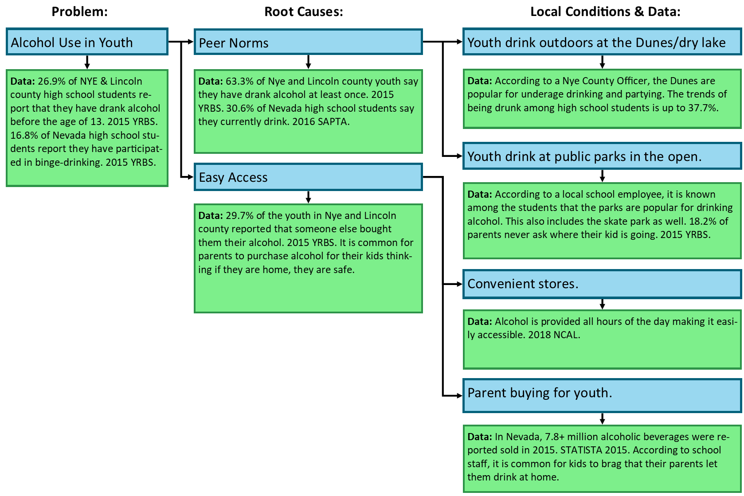
Marijuana

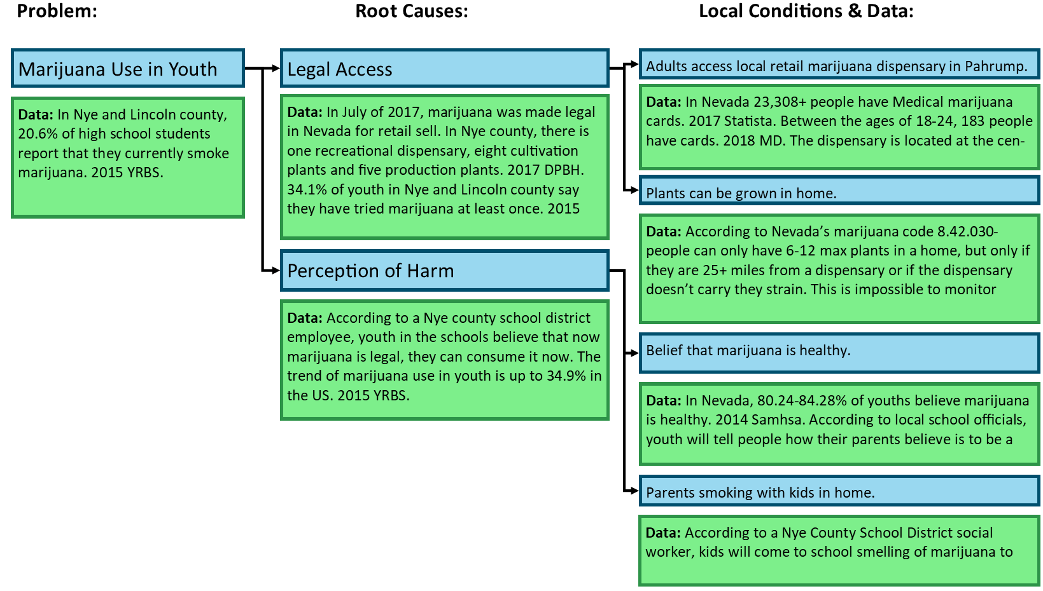

Rx Drugs

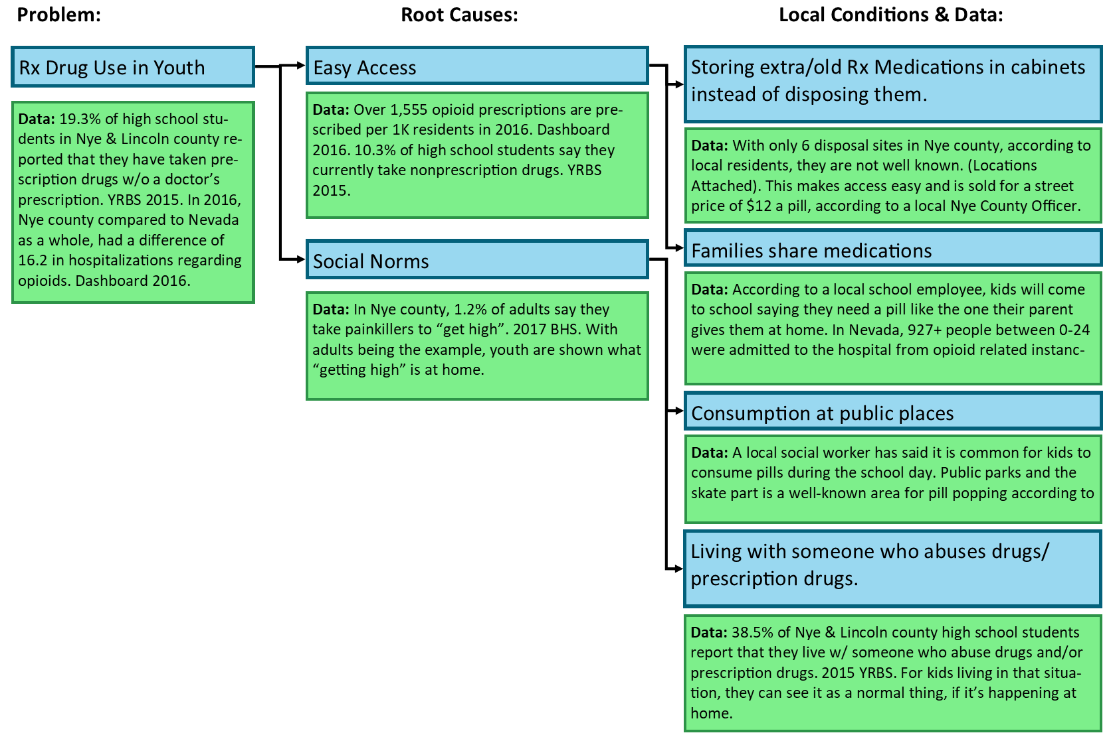

SPF Step 2: Capacity

NYECC is able to operate effectively across its three county service area due to the processes, systems and relationships that have been developed over the years. NYECC functions as a coalition and part of the coalition process is to engage local community member, key stakeholders, leaders and community agencies. In order to effective combat the substance abuse problem in Nye, Lincoln and Esmeralda Counties NYECC will continue to engage the 12 community sectors in the coalition process. During 2018-2021, NYECC will continue to supports this collaborative process in a number of ways:

- General Coalition Meeting: Located in Pahrump this group meets on the third Wednesday of each month. This group is predominately comprised of professionals and works to build local capacity and address gaps in services.

- HOPE Committee: Located in Pahrump this committee meets on the third Monday of each quarter. The APE (Assessment, Planning and Evaluation) and the Substance Abuse Task Force (SATF) make up the HOPE Committee. This committee focuses on needs assessment, capacity and systems development, planning and implementation and evaluation. The SPF model provides a process for the HOPE Committee to follow.

- Tonopah Coalition Meeting: Located in Tonopah this meeting is held the first Wednesday of each month. This group is composed of professionals, community leaders and concerned citizens. This group focuses on local capacity growing substance abuse prevention efforts.

- Lincoln County Coalition Meetings: Located in Panaca this meeting is held the fourth Tuesday of each month. This group is composed of professionals, community leaders and concerned citizens. These coalition members are being mentored by NYECC to become their own coalition and address substance abuse across Lincoln County.

Each community has the ability to form ad hoc committees in order to address any emerging issues that are identified or to provide a benefit to the community.

Nye, Lincoln and Esmeralda are rural counties located in southern Nevada. Each of these counties have areas that are considered to be medically underserved areas by Health Resource and Service Administration (HRSA). Each county is under-resourced and lacks infrastructure and systems that are an integral part of other communities.

Existing Resources |  | Gaps and Needs
State and Federal Funds to support substance abuse prevention | Funding & Resources | Adequate funding to address substance abuse prevention across the three counties
In-Kind Support |  | Increased inter-agency collaboration to secure funding
Donations
NYECC Sub-grant process for state funds (Substance Abuse Primary Prevention)
Sale to Minor Tobacco 18 – Fine to Individual | Laws, Policy and Community Norms | Raising minimum age of purchase to 21 for tobacco products
Sale to Minor Alcohol 21 – Fine to Individual |  | Alcohol sale to minor consequences to the businesses
Sale to Minor Marijuana 21 |  | Mandatory server seller training for alcohol in rural counties
Product placement for tobacco at retail stores |  | Increased awareness of clean indoor air act
Clean Indoor Air Act |  | Consistent enforcement of laws and policies
Additional taxes on tobacco, alcohol and marijuana products |  | Raise awareness for social host laws
Driving Under the Influence Laws |  | Raise awareness for local and state laws in regards to marijuana
Prescription Drug Monitoring Program |  | Increased compliance checks around tobacco, alcohol and marijuana
Good Samaritan Law |  | Real time overdose tracking system (ODMAPS)
MedReturn Location and Drug Take Back Days |  | Increased awareness of healthy community norms
Family Resource Center | Organizations, Programs and People | Increased youth organizations- EG: YMCA or Big Brother Big Sister
Evidence-based prevention programs- Project Magic, Positive Actions, Lifeskills |  | Increased substance abuse prevention providers
Youth advocacy groups- CYAC (Tonopah) & YACC (Pahrump) |  | Increase youth leadership
Scouts of America |  | Increase parent involvement and education
4-H |  | Increase transportation for individuals to participate in prevention programs and activities
Churches and youth groups |  | Increase evidence-based programs in school or community settings
Parenting classes |  | Expand mental health and public health providers
Local school district and school boards
Law Enforcement & Specialty courts- Drug Court
Treatment agencies- Westcare
Senior Centers

SPF Step 3 & 4: Planning and Implementation
Priority | Data Indicator | Outcome | Intervening Variables | Strategies | Activities
Neonatal & Infant Exposure to Substances | CDC, MMWR, 2014- 4.8 per 1,000 births | Decrease rates of NAS (neonatal abstinence syndrome), FAS (fetal alcohol syndrome) and marijuana-exposed babies. | Low perception of harm  Laws and norms favorable to use | Community Education  Community Awareness Campaign | Presentations specific to women of child-bearing age  Presentations specific to health care professionals and WIC representatives  Media- Print, TV & Radio, Social Media
Early Childhood & Elementary student use of tobacco, vape and alcohol | YRBS middle school survey – use before 11 years of age | Decrease the YRBS age of first use past 11 years of age for tobacco, vape and alcohol | Easy access- social availability (obtaining through friends and family)  Low perception of harm | School-based programming  Community-based programming  Environmental Strategies & Coalition Process  Community Awareness Campaign | Direct, evidence-based programming to youth  Parenting Classes  Advocacy around policy change  Peer-to-peer education  Media-Print, TV & Radio
Middle School students use of tobacco, vape, alcohol, marijuana and inhalants | YRBS middle school survey- ever use | Reduce the YRBS – ever use- question for tobacco, vape, alcohol, marijuana and inhalants | Low perception of harm  Easy social access (obtaining through friends and family)  Norms favorable to use | School-based programming  Community-based programming  School-based programming  Alternative Activities  Service Learning  Community Awareness Campaign  Environmental Strategies & Coalition Process | Direct, evidence-based programming to youth  Education to parents and community through community events- school open houses, health fairs and other means  Parenting Classes  Advocacy around policy change  Peer-to-peer education  Alcohol, tobacco and drug-free events  Service learning to connect youth to positive relationships and community  Media- Print, TV & Radio
High school students  Use of vape, alcohol, marijuana Rx pain medication, inhalants, and synthetic marijuana | YRBS high school survey-ever use for Rx paid medication, inhalants, and synthetic marijuana & past 30 day use for vape, alcohol and marijuana | Reduce the YRBS- ever use- question for Rx pain medication, inhalants and synthetic marijuana & past 30 day question for vape, alcohol, binge drinking, and marijuana | Norms favorable to use  Easy access  Low perception of harm | Community-based programming  School-based programming  Alternative Activities  Service Learning  Environmental Strategies & Coalition Process | Education to parents and community through community events- school open houses, health fairs and other means  Parenting Classes  Advocacy around policy change  Peer-to-peer education  Alcohol, tobacco and drug-free events  Service learning to connect youth to positive relationships and community  Media- Print, TV & Radio
Driving while impaired 16-adult | County Health Ranking- driving deaths that involved alcohol  YRBS high school survey driving while using marijuana in past 30 days | Decrease the number of deaths related to alcohol impairment  Decrease the number of high school students who report driving or driving with someone while using marijuana | Norms favorable to use  Easy access  Low perception of harm for marijuana impairment  Low consequences | Community Awareness Campaign  Environmental Strategies and Coalition Process | Education to parents and community through community events- school open houses, health fairs and other means  Advocacy around policy change  Media- Print, TV & Radio
Prescription Drugs- Opioids and Stimulants | Southern Nevada Health District Opioid Dashboard- opioid overdose deaths per 100k  CDC 2018 report death rate psychostimulants 7.5 per 100k | Decrease SNHD opioid dashboard- opioid overdose deaths per 100k  Decrease CDC psychostimulant death rate | Access and availability to drugs  Favorable attitudes towards the problem behavior | Evidenced-based community programming  Community Awareness Campaign  Environmental Strategies and Coalition Process | Education to parents and community through community events- school open houses, health fairs and other means  Advocacy around policy change  Alcohol, tobacco and drug free events  Media- Print, TV & Radio

3-Year Strategic Initiative

Data Driven Decision Making
The NYECC is dedicated to strategically improving the organization and operations by using data to guide decisions. Specific goals and objectives utilizing data-based improvement are outlined below.
Goal 1: Committee Operations. Committees at the NYECC do a significant amount of work to help improve community health outcomes. As such, ensuring that committees are using data and planning to guide their operations is essential.
Objective 1. Formalize and standardize process for committees to develop annual goals and objectives.
Objective 2. Standardize documentation for committees, including all sign-in sheets, annual goals sheets, contact sheets, and other documents normally used.
Objective 3. Develop a simplified evaluation process for committees to complete at the end of the year to assess their progress toward goal completion.
Goal 2: Project Impact Implementation. The NYECC will implement the Project Impact mixed-methods evaluation process and investigate its expanded use.
Objective 1: The NYECC will select a program to pilot the Project Impact evaluation process and will implement the learned evaluation procedures.
Objective 2: The NYECC will convene a committee to discuss the Project Impact process and evaluation results and the possibility of expanding its use.
Objective 3: The NYECC will publish the results of the committee evaluation of the Project Impact process that will include either a reason for not expanding the process or a timeline for expanding the use of the process, depending on results.

Data Access for Partners
NYECC partners use data regularly for grant writing, needs assessments, and program evaluation. However, data is not readily available, and data systems are varied and sometimes difficult to manage. To help NYECC partners succeed, access to quality data in a single location is essential. As such, NYECC will build a data source and repository that will be freely available for all NYECC partners and the public.
Goal 1: Collect and store relevant county, state, and national data.
Objective 1. Evaluation all data sources and create central repository of relevant data sources.
Objective 2. Develop process to ensure data collected is kept up-to-date and as reliable as possible.
Objective 3. Develop an interactive data dashboard that will help partners access the data they need quickly and efficiently.
Goal 2: Develop an interactive strategic plan for partners to access.
Objective 1. Create a strategic plan in a format that can be interactive and available on the web for partner access.
Objective 2. Ensure NYECC goals and priorities are searchable and clear so that partners can develop appropriate programs that match funding.
Objective 3. Provide access to training on website and strategic plan as needed.

SPF Step 5: Evaluate

Program Evaluation

The NYECC has always engaged in a holistic approach to gauging effectiveness.

Internal Evaluation
Project personnel are the first step in gauging effectiveness, as they are the workers with intimate knowledge of the programmatic processes. These front-line workers monitor programs, collect data, and manage for fidelity, contractual responsibilities, and scope of work.

Continuous Improvement
While organizational memory has assisted the NYECC in evaluation efforts, an effort to improve and expand internal evaluation is always underway. A recent addition (2018) to the internal evaluation toolbox is the addition of the Project Impact method of mixed-method evaluation. This evaluation method includes intensive training in both qualitative and quantitative data gathering techniques as well as a guided evaluation schedule. A pilot program was selected to be evaluated using the learned Project Impact techniques, and additional analysis will be conducted to study the goodness of fit of this evaluation method.

External Evaluation
While front-line workers are an excellent source of information and insight, the NYECC also contracts with outside evaluators to provide higher-level statistical analysis and program impact data. These evaluations can be grant or project focused, dependent on NYECC needs.

Putting Evaluation Data to Use
Finally, the hard work of evaluators and data gatherers would be wasted if not for the work of the evaluation committee, which both interprets data and drafts recommendations for improvements based on lessons learned. This combination of internal and external evaluation, as well as the addition of new and innovative evaluation methods, allows for a robust evaluation process that both respects the front-line workers, the community, as well as the skills of outside experts.

Sustainability
Sustainability affects all levels of the coalition and its activities. It is necessary to maintain an adequate amount of both staffing and material resources to accomplish the short-term and long-term goals of the coalition.
NYECC hires staff with skills, talents, experience, energies, determination and belief in their work to ensure commitment to the process is maintained.
Other human resources that are vital to sustainability of the coalition are the general membership. Members of the coalition are both committed to their own agencies and organizations and also to the work that they are involved in with the coalition. NYECC is committed to continued recruitment of new members and support of current members.
Material resources are integral to any business, agency or organization. NYECC looks at available funding streams for programs and projects currently being implemented, future programs and projects that are identified by the APE Committee and for other agencies/organizations programs.
NYECC practices the Seven Habits of Highly Sustainable Coalitions that consist of guarding capacity, tracking coalition progress, focusing on the goals, maintaining local support, added value by collaboration, telling the story, continuing to learn/keeping an open mind and system integration which when incorporated into an organization or agencies processes, it can and will help sustain programs.
NYECC’s Sustainability Plan starts with the overall coalition goals, assessing the resources currently available within the communities to support that work, collaboration with other agencies and organizations providing services, evaluating barriers and future needs and continuing to be adaptable when necessary.

Public Trust
NyE Communities Coalition is deeply protective of its integrity within the community because there must be trust in the agency in order to give accurate information. Trust is earned and requires that confidences be maintained and purposes disclosed above the level that the law requires. NYECC is committed, in the first place, to not collecting personally identifiable health information when there is no need and suppressing identifiers when the collection of personally identifiable data is required. As a result of funding requirements many of our agency personnel are quite skilled in implementing privacy safeguards. A partnering agency on an NYECC project is required to be compliant with applicable privacy laws such as HIPAA or 42 CFR Part 2 when applicable, including keeping copies of notice and consent on file. Furthermore, consent must be informed within the meaning of the law: the full purpose of the data collection must be disclosed. Partnering agencies are also required to use restraint, respect, and common sense in their everyday dealings with the public on NYECC’s behalf.

Cultural Competence
NYECC includes Cultural Competency in all aspects of planning and implementation. NYECC also integrates cultural competency into every step of the SPF process.
Coalition staff, members, board members and volunteers are actively recruited to ensure a diverse population. NYECC uses a tool that was provided during a training by Boardsource that allows members and staff to self-identify by a variety of backgrounds including economics, education level, geography, race, ethnicity, gender, and sexual orientation. Information was analyzed to determine if there are gaps in the group and to make sure that representation was indicative of the population that is being served.
NYECC also “houses” an AmeriCorps participant who is a Hispanic Advocate. This volunteer helps with translations, interpretations, and ensures that materials are culturally appropriate. Another AmeriCorps volunteer has been trained on how to review documents and brochures for readability and comprehension following the Title X model.

